New Eagle Scout Reception
Professional Photography
Options & Pricing
The following options are available for purchase:
- A digital copy via email ($15 per background)
- 8x10 canvas print ($30 includes shipping and digital copy emailed)
- 10x12 ($35 includes shipping and digital copy emailed)
- 16x20 ($50 including shipping and digital copy emailed) canvas prints –

You will receive an email with the image for your approval before the prints are shipped.
Please complete the form below and submit it along with your payment
First Name___________________________________ Last Name________________________________
Eagle Scout Name_______________________________________________
Address_______________________________________________________
City, State, Zip__________________________________________________
Email _________________________________________________________
Phone_________________________________________________________
Please indicate the quantity you would like to purchase:
____Digital copy via email ($15) Which background option: A:____ B:____ C:____ D: ____ E: ____
____8x10 ($30)
____10x12 ($40)
____16x20 ($50 including shipping) canvas prints
TOTAL DUE $__________ (For walkups only or additional orders for preregistered photos)
Payment Method Check_____ Cash____ Credit Card____
Questions: Contact Steven Willis at scwillis60@yahoo.com

Option A
Option B
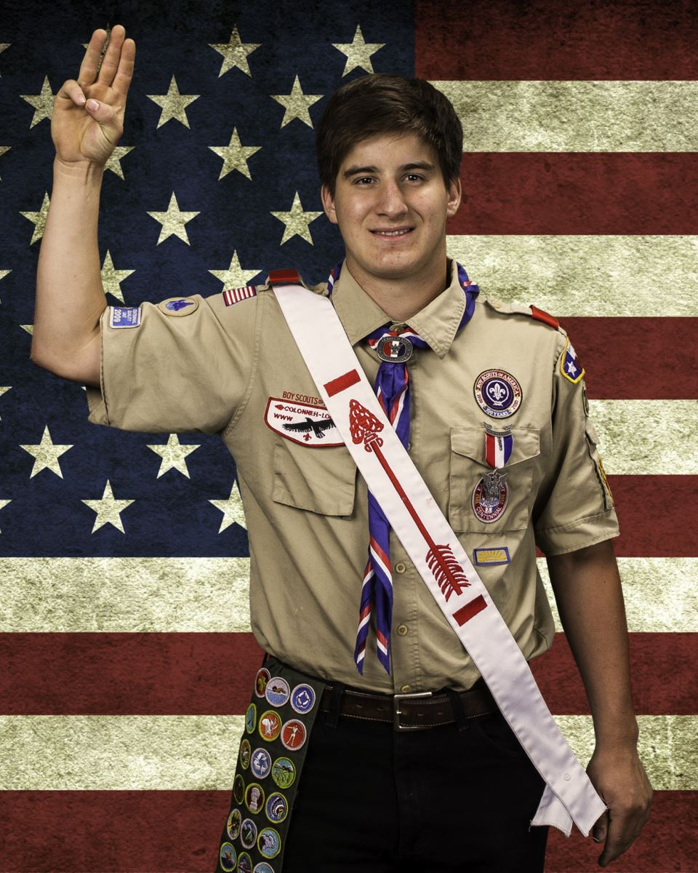
Option C
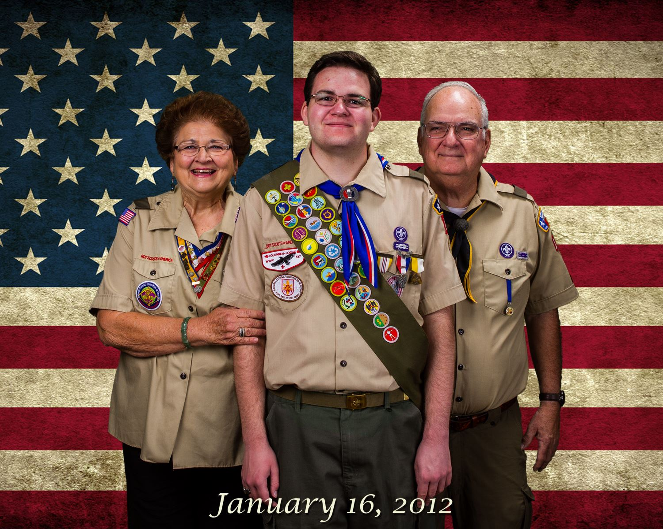
Option D

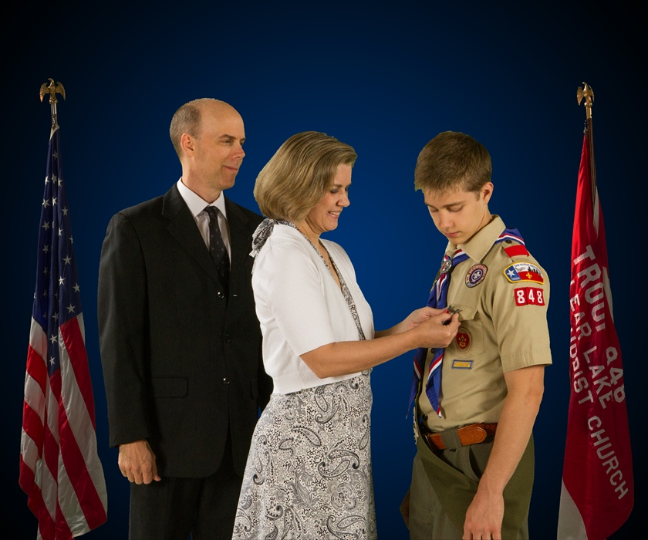
Option E

